SORT_TUBE MINIMUM VIABLE PRODUCT

## 

## ARCHITECTURE:

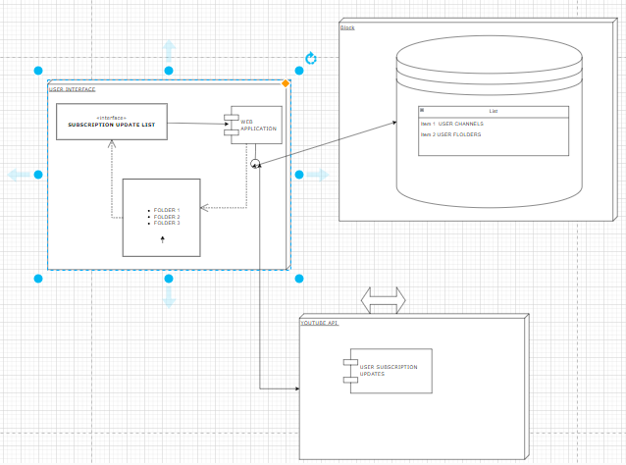

## DATA MODEL:

## 

## USER STORY:

* A user logs in with their google youtube account.
* The app fetched all the youtube channels to which they are subscribed to. Which is saved to the database for that user.

For future work:

Then the user creates buckets or folders with a specific theme.

The user then assigns channels to each bucket.

Anytime a bucket is opened, the last 24 hours worth of updates from each channel on the bucket is displayed.